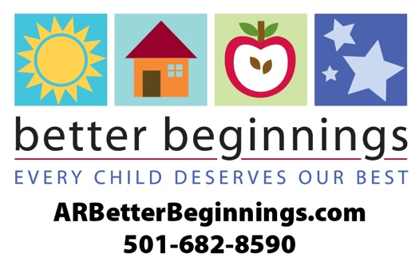

**News Release**

**For more information, contact:**

Kim E. Stinson

Administrator/Director

Office: (501)865-2787

Email: kim@lillionsdaycare.org

**FOR RELEASE: July 11, 2022**

**LIL LIONS DAYCARE LLC in Bismarck Earns Next Step in Arkansas’s Quality Rating System**

**Bismarck, ARK., July 11, 2022** ⎯ LiL LiOnS DaYcArE has earned a **Better Beginnings** 2-starrating in high quality child care. Better Beginnings is Arkansas’s quality rating improvement system for child care, early education and school-age programs that have gone above and beyond state minimum licensing requirements. Better Beginnings distinguishes the quality of each child care facility by a 1, 2 and 3-star rating system.

“Research shows that the early months and years following birth really do matter, that maximum brain development happens during the first five years of life – before children are ‘officially’ in school. We want children to have a better beginning to their education,” said Tonya Williams, Director, Division of Child Care and Early Childhood Education**.**

Better Beginnings provides curriculum based on the early learning and development guidelines: math, science and literacy. Through a high-quality learning environment, children develop social and academic skills that lead to school success.

Better Beginnings connects Arkansas families with information and child care that help children experience a safe, happy and healthy childhood. For more information on Better, visit **ARBetterBeginnings.com** or call **1-501-682-8590.**

###